Algebra 1 (CCSP)

Section 1.2: Solving Equations by Adding or Subtracting
Date: ________________________________
Objectives: Students will be able to solve one-step equations in one variable by using addition and subtraction.
Main Idea | Notes
Exploration: | 1.2 Exploration: Solving Equations by Adding or Subtracting
Equations and Solutions of Equations: | An equation is a statement that _______________________________________________________________________  ________________________________________________________________________________________.  Give 2 examples of equations:  _________________________________________ ___________________________________________  A solution is a __________________________________________________________________________________________  _______________________________________________________________________________________.  Example: Is x = 4 is a solution of 3x – 5 = 7? Explain your answer.  To find solutions, _____________________________________________________________________________________.  Do this by using _______________________________________________________________________________________.  This will undo _________________________________________________________________________________________.
A Question of Balance:  A Question of Balance (Continued): | Think of equations like a scale. The two sides on a balanced scale must be  ________________________________________________________________________________.  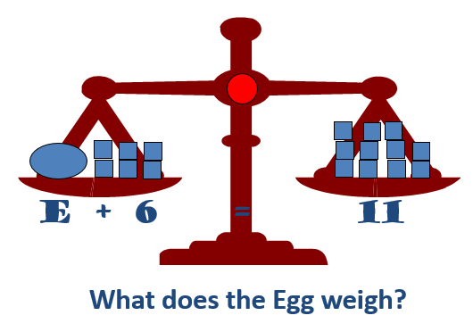  The two sides of an equation are __________________________________________________________________.  Are the left and right side balanced on this scale below? Is this a correct equation?  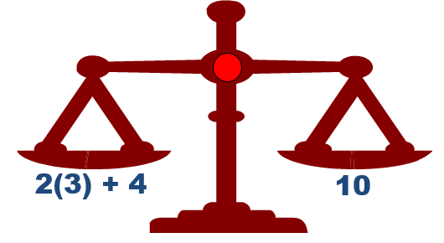  When you do something to one side of the equation, _______________________________________________  ___________________________________________________________________________________________________________.
A Question of Balance (Continued): | Are the left and right side balanced on this scale below? Is this a correct equation?  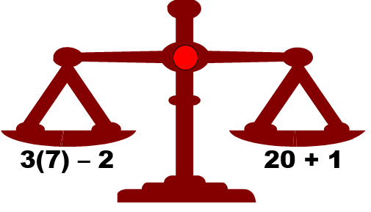  What happens if we change one side of a balanced equation?  _________________________________________________________________________________________________________.  What do we need to do to fix this?  _________________________________________________________________________________________________________.
Solving Equations by Adding or Subtracting: | Now let’s solve an equation by _________________________________ or ____________________________________  to each side of the equation. Always keep it ______________________________________________________!  Example: Solve x + 7 = 15  Looking at the balance:  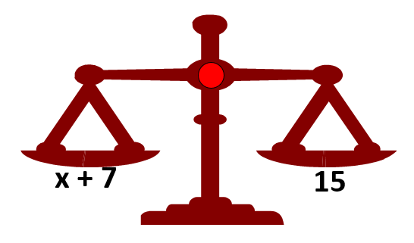  What do you need to do to both sides to get x alone?  What does x equal? __________________________
Property of Equality: | The property of equality says that you can _____________________ or ___________________________________  the same ____________________________________ to both sides of an _______________________________________,  and the statement will _______________________________________________________________________.
Example 1: Solving Equations by Adding or Subtracting | Solve for the variable. Show all of your work!  - x – 7 = 12  - 20 + h = 41
Example 2: Solving Equations by Adding or Subtracting | Solve for the variable. Show all of your work!  - x + 127 = –93  - w – 3.2 = 1.08
Example 3: Solving Equations by Adding or Subtracting | Solve for x. Show all of your work!  - 0.7 = x + 0.4  - $\frac{2}{5}$ = x – $\frac{1}{5}$
Example 4: Solving Equations by Adding or Subtracting | Solve for the variable by adding the opposite. Show all your work!  - -8 + b = 2  - $-\frac{5}{11}+p= -\frac{2}{11}$  - $-\frac{3}{4}+z=\frac{5}{4}$  - –11 + x = 33
Example 5: Real-World Application | Over 20 years, the population of a town decreased by 275 people and now has a population of 850.  Write and solve an equation to find the original population.
Exit Ticket: | On a separate piece of paper, describe how the properties of equality are like a balanced scale.  (We will share these with the class and I will collect this for a classwork grade)
Homework: | 1.2 Additional Practice Worksheet

