Algebra 1 (CCSP)

Section 1.4: Solving Two-Step and Multi-Step Equations
Date: ________________________________
Objectives: Students will be able to solve equations in one variable that contain more than one operation.
Main Idea | Notes
Exploration: | 1.4 Exploration: Solving Two-Step and Multi-Step Inequalities
Different Steps to Create Equivalent Equations:  Example 1: Solving a Two-Step Equation using the Balance | Step Given Equation Equivalent Equation  2x – x = 4  x + 1 = 6  2x = 6  2 = x  Solve 3x + 5 = 12  Take another look at the balance:  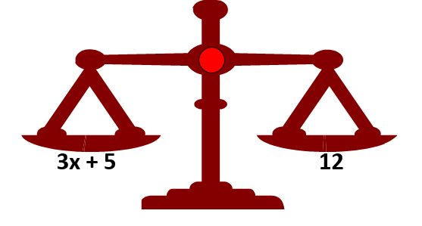  What would you do first to get the x alone? Make sure it remains balanced!  Now we are left with this on our balance:  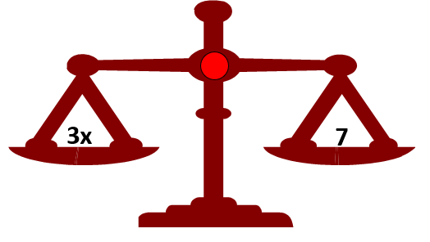  What would you do next to get the x alone? Make sure it remains balanced!  So what does x equal? Show it on the balance below:
Example 2: Solving Two-Step Equations | Solve for the variable. Show all of your work!  - $8m-10=36$  - $\frac{w}{6}+17=31$
Example 3: Solving a Two-Step Equation with Fractions | Solve for the variable. Show all of your work!  $$\frac{q}{15}-\frac{1}{5}=\frac{3}{5}$$
Example 4: Simplifying Before Solving  Example 4: Simplifying Before Solving | Solve for the variable. Show all of your work!  - 8x – 21 – 5x = -15  - 10y – (4y + 8) = -20  - -2(3 – d) = 4  - 4(x – 2) + 2x = 40
Example 5: Real-World Application | Sara belongs to a music club. She can buy a discount card for $19.95.  This card allows her to buy CDs for $3.95 each.  After one year, Sara has spent $63.40.  Write and solve an equation to find how many CDs Sara bought during the year. Let c = the number of CDs
Example 6: Solving for a Variable to Find the Value of an Expression  Example 6 (Continued): Solving for a Variable to Find the Value of an Expression | - If 4a + 0.2 = 5, find the value of a – 1.  - If 3d – (9 – 2d) = 51, find the value of 3d.
Exit Ticket: | On a separate piece of paper, answer the following questions.  (We will share these with the class and I will collect this for a classwork grade)  - What are the steps you would follow to solve 2x + 1 = 7?  - How is the procedure different from the one you would follow to solve 2x – 1 = 7?
Classwork: | 1.4 Technology Lab
Homework: | 1.4 Additional Practice Worksheet

