Algebra 1 (CCSP)

Section 1.9: Applications of Proportions
Date: ________________________________
Objectives: Students will be able to use proportions to solve problems involving geometric figures.
Students will be able to use proportions and similar figures to measure objects
indirectly.

Main Idea | Notes
Exploration: | 1.9 Exploration: Applications of Proportions
Vocabulary: Similar Figures | Similar figures have exactly the same _______________________________, but not necessarily the  same ____________________________.  ____________________________________________________________________________________and  _____________________________________________________________________are in the same relative position.  Similar figures have _________________________________________________________ that are  ____________________________________________ and ___________________________________________________________  that are _____________________________________________.  When stating two figures are similar, use the symbol _____________.  Make sure corresponding vertices are in the __________________________________________________.  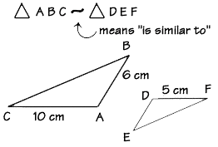  Why would be incorrect to write $∆ABC\sim ∆EDF$?
Vocabulary: Similar Figures | Similar Figures  $$ABCD\sim WXYZ$$  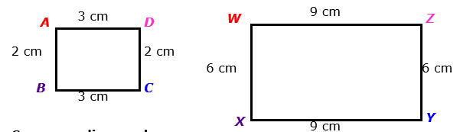  Write down the corresponding angles:  ______________________________________________________________  ______________________________________________________________  ______________________________________________________________  ______________________________________________________________  Write down the corresponding sides:  ______________________________________________________________  ______________________________________________________________  ______________________________________________________________  ______________________________________________________________  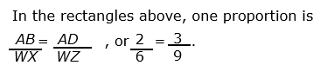  What are some other proportions?
Example 1: Missing Measures in Similar Figures | a) $∆ABC\sim ∆EFD.$Find the missing length y and the measure of <D.  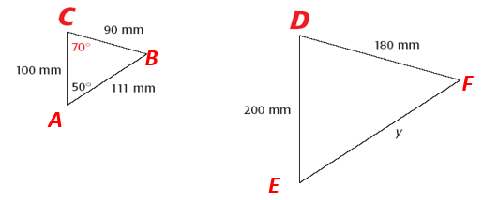  b) $MNPQ\sim RSTU.$Find the missing length y, x, and the measure of Z°.  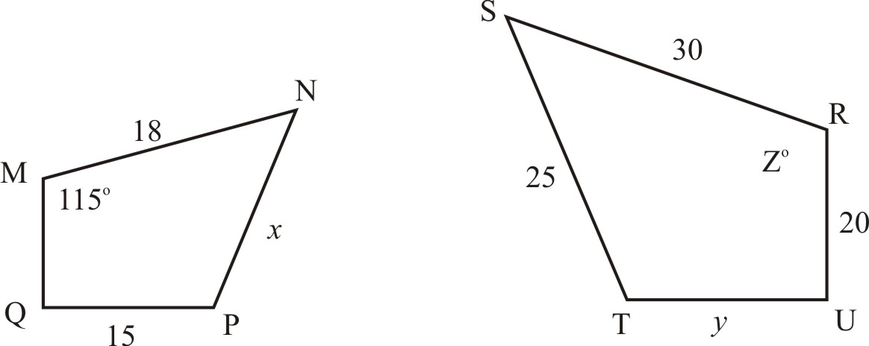
Exit Ticket: | List down as many pairs of real world items that appear to be similar figures.
Homework: | Punchline 135
Vocabulary: Indirect Measurement | Indirect Measurement is solving a proportion involving _____________________________________________  to find a ________________________________________ that is not easily ________________________________________.  If two objects form ___________________________________________________________ with the ground, you can  apply indirect measurement using their ______________________________________________.
Example 2: Using Indirect Measurement to Solve Real-World Problems | A totem pole casts a shadow 45 feet long. At the same time, a 6 foot tall man casts a shadow that is 3 feet long. Find the height of the totem pole.
Example 3: Using Indirect Measurement to Solve Real-World Problems | A flag pole casts a shadow that is 75 feet long. At the same time, a 6 foot tall man casts a shadow that is 9 feet long. Find the height of the flag pole.
Vocabulary: Scale Factor | If every dimension of a figure is multiplied by the _____________________________________________________,  the result is a ____________________________________________________________.  The multiplier is called a _______________________________________________________________________.
Example 4: Using Scale Factors to Create Similar Figures | Every dimension of a 2 by 4 rectangle is multiplied by 1.5. Draw this below:  - How is the ratio of the perimeters related to the ratio of the corresponding sides?  Ratio of perimeters: ______________________________  Ratio of sides:___________________________________  - How is the ratio of the areas related to the ratio of the corresponding sides?  Ratio of areas: _________________________________  Ratio of sides:_____________________________________
Example 5: Using Scale Factors to Create Similar Figures | Every dimension of a cylinder with radius 4cm and height 6cm is multiplied by ½. Draw this below:  How is the ratio of the volumes related to the ratio of the corresponding dimensions?  (Hint: Volume of a cylinder = $πr²h$)  Ratio of the radii: ______________________________  Ratio of the heights: ______________________________  Ratio of the volumes: _____________________________
Exit Ticket: | On a separate piece of paper, answer the following question.  (We will share these with the class and I will collect this for a classwork grade)  - If you know the lengths of the sides of two figures, how can you show that the figures are similar?  - Draw two similar figures
Homework: | 1.9 Additional Practice Worksheet

