Algebra 1 (CCSP)

Section 2.1: Graphing and Writing Inequalities
Date: ________________________________
Objectives: Students will be able to identity solutions of inequalities in one variable.
Students will be able to write and graph inequalities in one variable.

Main Idea | Notes
Exploration: | 2.1 Exploration: Graphing and Writing Inequalities
Vocabulary: Inequalities | An ___________________________________________________ is a statement that two quantities are not equal.  The quantities are compared using one of the following:  < _______________________________________  > _______________________________________  ≤ _______________________________________  ≥ _______________________________________  ≠ _______________________________________  A _________________________________________________________________________________ is any value that makes the inequality true.
Example 1: Solutions of Inequalities | Describe the solutions of x – 6 ≥ 4 in words. Let’s test some values. What values of x will work?  x = -2  x = 5  x = 9  x = 10  x = 11  Solution: _________________________________________________________________________
Graphing Inequalities: | We can use a graph to show all of the solutions to the last example.  Solution: All real numbers greater than or equal to 10.  x ≥ 10
Graphing Inequalities: | Use an ________________________ circle for < and >.  Use a _________________________ circle for ≤ and ≥.  If it is less than, shade to the ___________________________.  If it is greater than, shade to the ________________________.
Example 2: Writing and Graphinhg Inequalities | Write each inequality in words. Then Graph each inequality.  - m≥ ¾  b) t < 5(-1 + 3)
Example 3: Writing Inequalities from Graphs  Example 3 (Continued): Writing Inequalities from Graphs | Write the inequality shown by the graph.  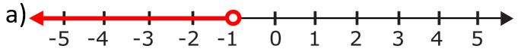  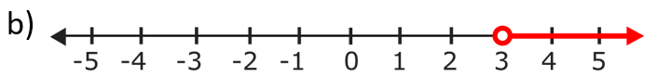  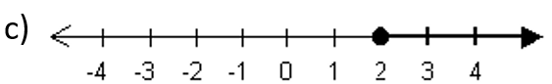  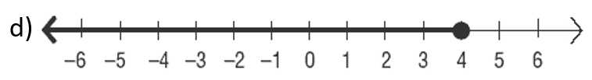
Example 4: Real World Application | The members of a crew team can weigh no more than 165 pounds each.  - Write an inequality for the acceptable weights of the team members.  - Graph the solution.
Exit Ticket: | Explain the difference between x > 2 and x ≥ 2.  Use as many examples as possible.  ( Do this On a separate piece of paper. I will collect this for a grade)
Classwork: | Graphing Inequalities Worksheet (Double Sided)
Homework: | 2.1 Additional Practice Worksheet

