Algebra 1 (CCSP)

Section 2.4: Solving Two-Step and Multi-Step Inequalities
Date: ________________________________
Objectives: Solve inequalities that contain more than one operation.

Main Idea | Notes
Exploration: | 2.4 Exploration: Solving Two-Step and Multi-Step Inequalities
Introduction: | Inequalities that have more than one operation require ______________________________________________ to solve.  Use ______________________________________ operations to isolate the variable.
Example 1: Solve and Graph the Inequalities | Solve each inequality and graph its solution.  - 45 + 2b > 61  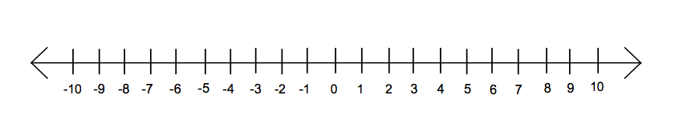  - 8 – 3y ≥ 29
Solving more Complicated Inequalities: | To solve more complicated inequalities, you may need to simplify either side of the inequality first by using:  - _______________________________________________________________________  - _______________________________________________________________________  - _______________________________________________________________________
Example 2: Solve and Graph the Inequalities | Solve each inequality and graph its solution.  - 2 – (-10) > -4t  - -4(2 – x) ≤ 8  - $\frac{2}{3}f+ \frac{1}{2}>\frac{1}{3}$
Example 3: Writing and Solving Inequalities in the Real-World | To win the blue ribbon for the “Heaviest Pumpkin Crop” at the county fair, the average weight of John’s two pumpkins must be greater than 819 lbs. One of his pumpkins weighs 887 lbs.  How many pounds must the second pumpkin weigh in order for him to win the blue ribbon?
Exit Ticket: | DESCRIBE two sets of steps for solving the inequality $\frac{x+5}{3}>7.$  What is the solution?  ( Do this on a separate piece of paper. I will collect this for a grade)
Homework: | Multi-Step Inequalities Worksheet

