Algebra 1 (CCSP)

Section 2.5: Solving Inequalities with Variables on Both Sides
Date: ________________________________
Objectives: Solve Inequalities that contain variable terms on both sides.
Main Idea | Notes
Exploration: | 2.5 Exploration: Solving Inequalities with Variables on Both Sides
Solving with Variables of Both Sides: | Use the properties of inequality to collect all the ___________________________________ terms on one  side and __________________________________ terms on the other.  Then solve using the same ________________________________________ in the last section.
Example 1: Solve and Graph the Inequalities | Solve each inequality and graph its solution.  - x < 3x + 8  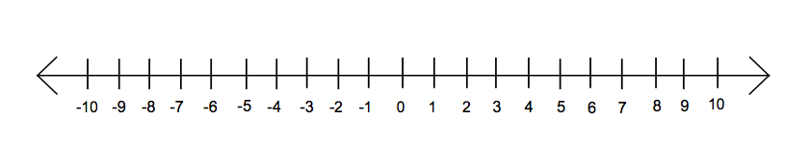  - 6x – 1 ≤ 3.5x + 4
Example 2: Solving Inequalities Word Problem | The Home Cleaning Company charges $312 to power-wash the siding of a house plus $12 for each window. Power Clean charges $36 per window, and this includes the power-washing the siding.  How many windows must a house have to make the total cost of the Home Cleaning Company less expensive than Power Clean?
Simplifying Inequalities: | You may need to _______________________________ one or both sides of the inequality before solving it.  Look for _____________________________ and places to use the _____________________________________________.
Example 3: Solve and Graph the Inequalities  Special Cases: | Solve each inequality and graph its solution.  - 2(x – 3) > 6 + 3x – 3  - 0.9y ≥ 0.4y – 0.5  Some inequalities are ___________________________ no matter what you plug into the variable.  These inequalities have a solution of ___________________________________________________________________.  Some inequalities are ____________________________________ no matter what you plug into the variable.  These inequalities have _______________________________________________________________.
Example 4: Solve and Graph the Inequalities | - 2x – 7 ≤ 5 + 2x  - 2(3y – 2) – 4 ≥ 3(2y + 7)
Exit Ticket: | Explain how you would collect the variable terms to solve the inequality 5c – 4 > 8c + 2.  What is the solution?  ( Do this on a separate piece of paper. I will collect this for a grade)
Classwork: | Solving Inequalities with Variables on Both Sides
Homework: | 2.5 Additional Practice Problems Worksheet

