Algebra 1 (CCSP)

Section 2.6: Solving Compound Inequalities
Date: ________________________________
Objectives: Students will be able to solve compound inequalities in one variable.
Students will be able to graph solution sets of compound inequalities in one variable.

Main Idea | Notes
Algebra Lab: | 2.6 Algebra Lab: Truth Tables and Compound Statements
Exploration: | 2.6 Exploration: Solving Compound Inequalities
Vocabulary: Compound Inequalities  Vocabulary: Compound Inequalities (Continued) | When two inequalities are combined into one statement by the words AND or OR, the result is a  _______________________________________________________________________________.  With AND inequalities, you can ______________________________________________ them.  Examples: Write and graph the following compound inequalities  - All real numbers greater than 1 AND less than 4.  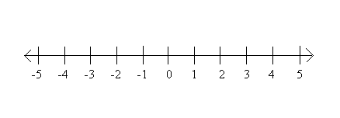  - All real numbers greater than or equal to 1 AND less than or equal to 4.  - All real numbers less than 1 OR greater than 4.  - All real numbers less than or equal to 1 OR greater than or equal to 4.
Example 1: Writing and Graphing Compound Inequalities | The pH level of swimming pool water must be between 7.2 and 7.6 inclusive.  Write a compound inequality to show the pH levels that are within the range.  Graph the solutions.  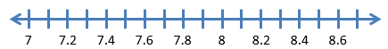
Compound Inequalities Involving AND:  Example 2: Solving and Graphing Compound Inequalities | When graphing the solutions of a compound inequality involving AND, use the idea of  ____________________________________________________________ sections.  The overlapping region is called the ________________________________________________________.  Solve each compound inequality and graph the solutions.  - -5 < x + 1 < 2  - 8 < 3x – 1 ≤ 11
Compound Inequalities Involving OR: | When graphing the solutions of a compound inequality involving OR, use the idea of  _________________________________________________ sections.  The combined regions are called the ____________________________________.
Example 3: Solving and Graphing Compound Inequalities  Example 3 (Continued): Solving and Graphing Compound Inequalities | Solve each compound inequality and graph the solutions.  - -4 + a > 1 OR -4 + a < -3  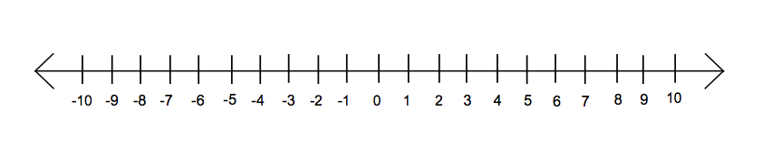  - 4x ≤ 20 OR 3x > 21
Special Cases: | Every solution of an inequality involving AND must be a solution of __________________________ parts of the compound inequality.  If no numbers are solutions of BOTH, then it has ____________________________________________________.  The solutions of an inequality involving OR are not always two _____________________________________ sets of numbers.  There may be numbers that are solutions to ____________________ parts of the compound inequality.
Example 4: Write the Compound Inequality from the Graph | Write the compound inequality shown by each graph.  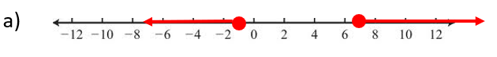
Exit Ticket: | Describe how to write the compound inequality  y > 4 AND y ≤ 12  without using the joining word AND.  ( Do this on a separate piece of paper. I will collect this for a grade)
Classwork: | Connecting Algebra to Geometry: Triangle Inequality
Homework: | 2.6 Additional Practice Problems Worksheet

